**STATISTICS**

**Question-1:**

Here the correlation coefficient between SAT scores and college GPA is 0.7>0.It indicates a positive correlation between these two.This means whenever GPA will increase,SAT score will increase,and whenever GPA will decrease,SAT score will also decrease and vice versa.

Also,its 0.7,nearer to 1.This means this is a very strong positive correlation between SAT score and college GPA.

**Question-2:**

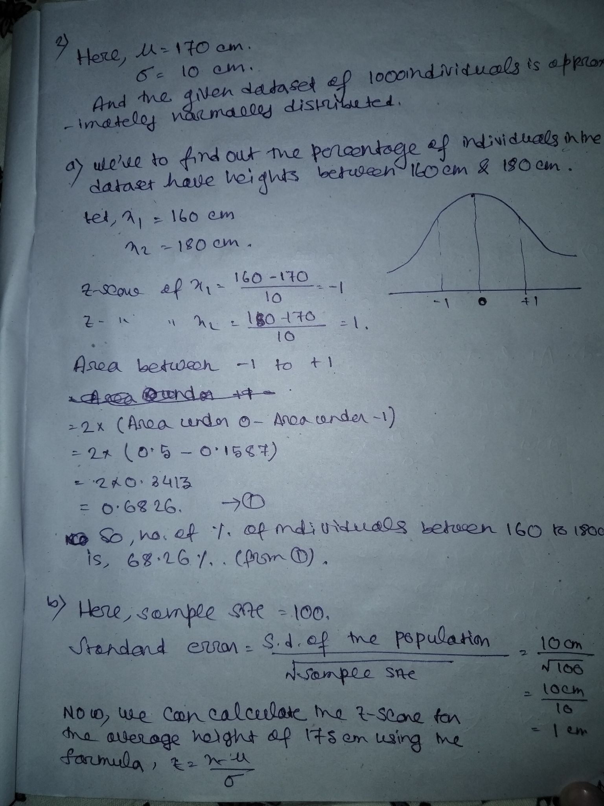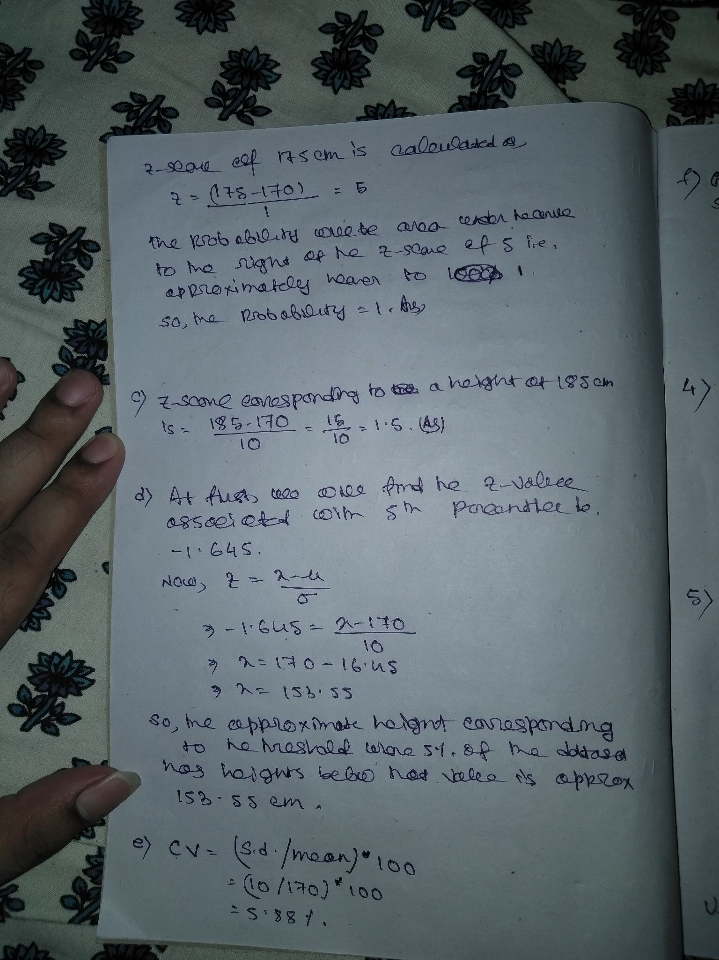

**Question-3:**

**Question-4:**

**Question-5:**

**Question-6:**

**Question-7:**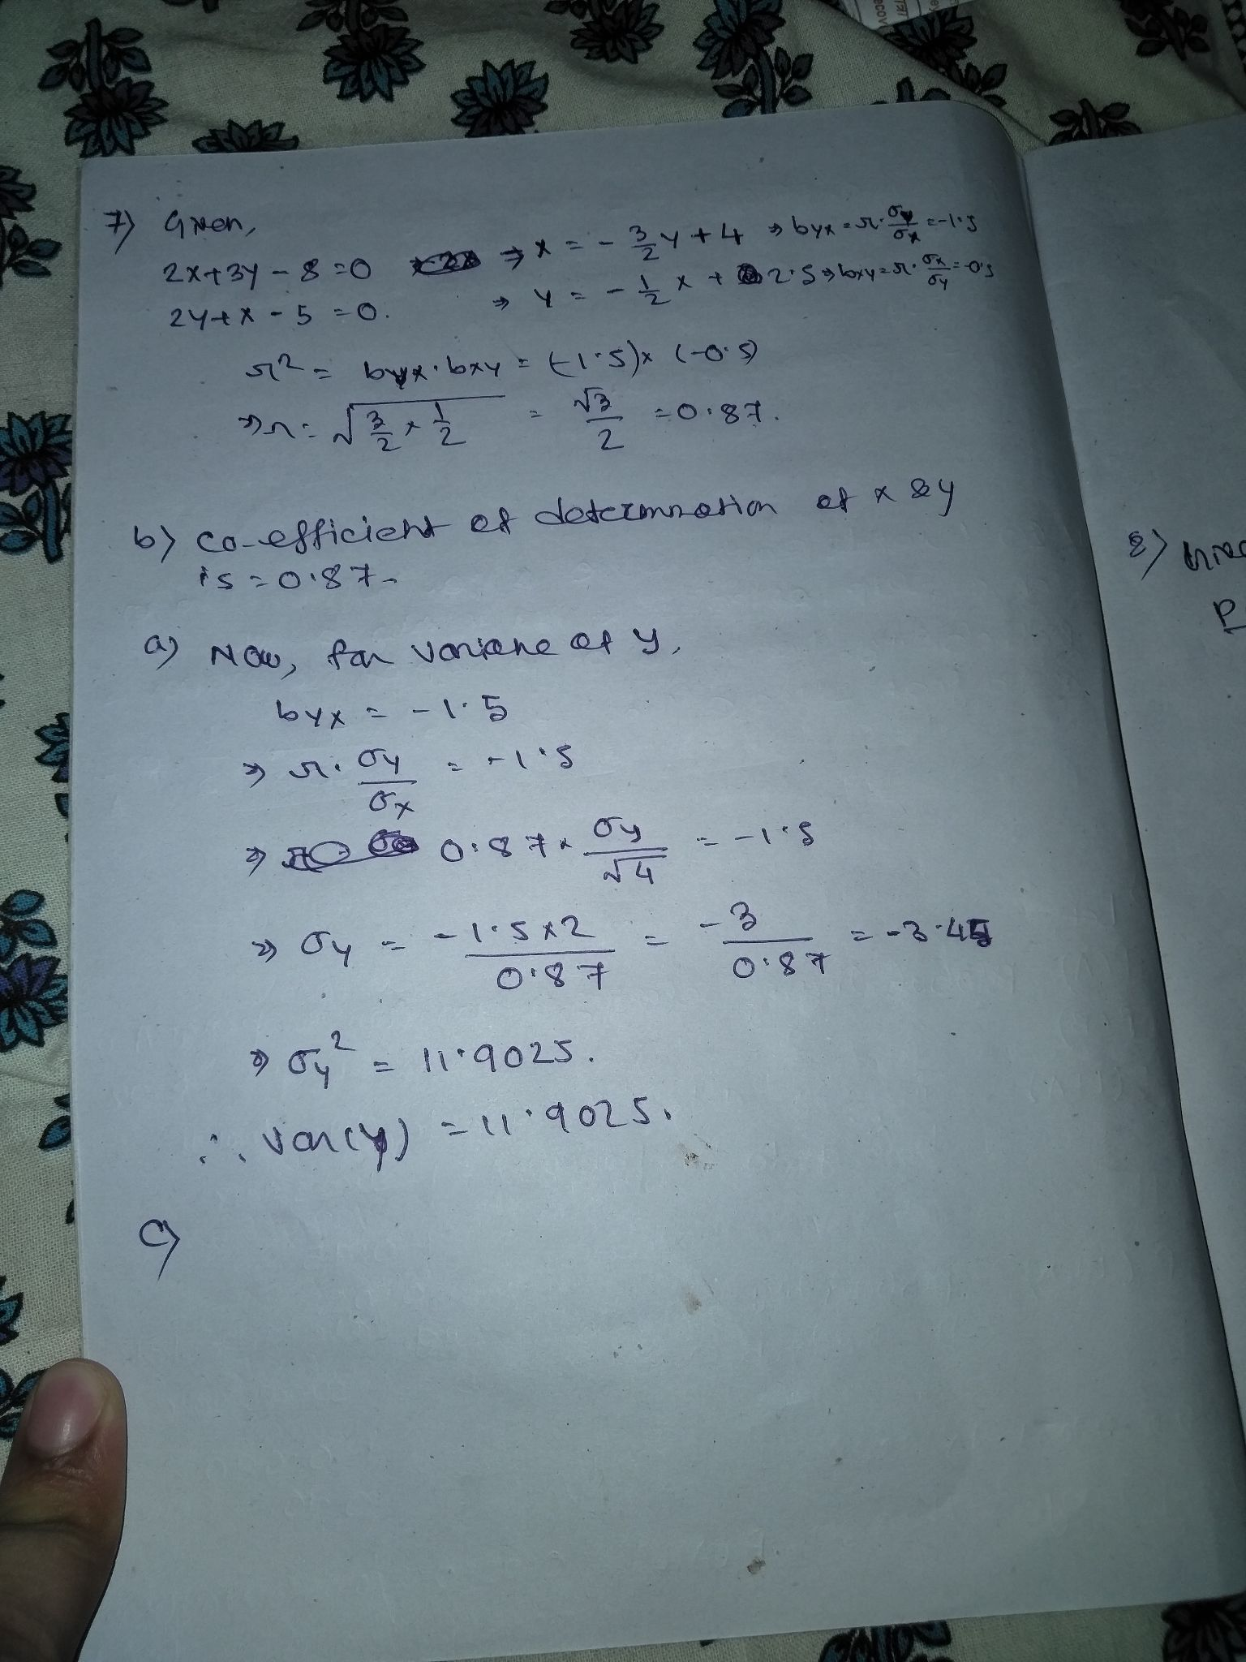

**Question-8:**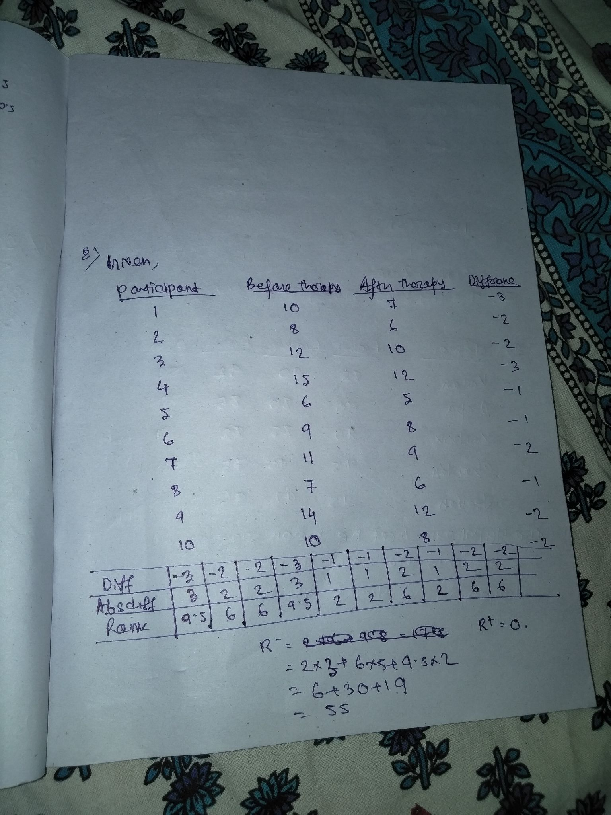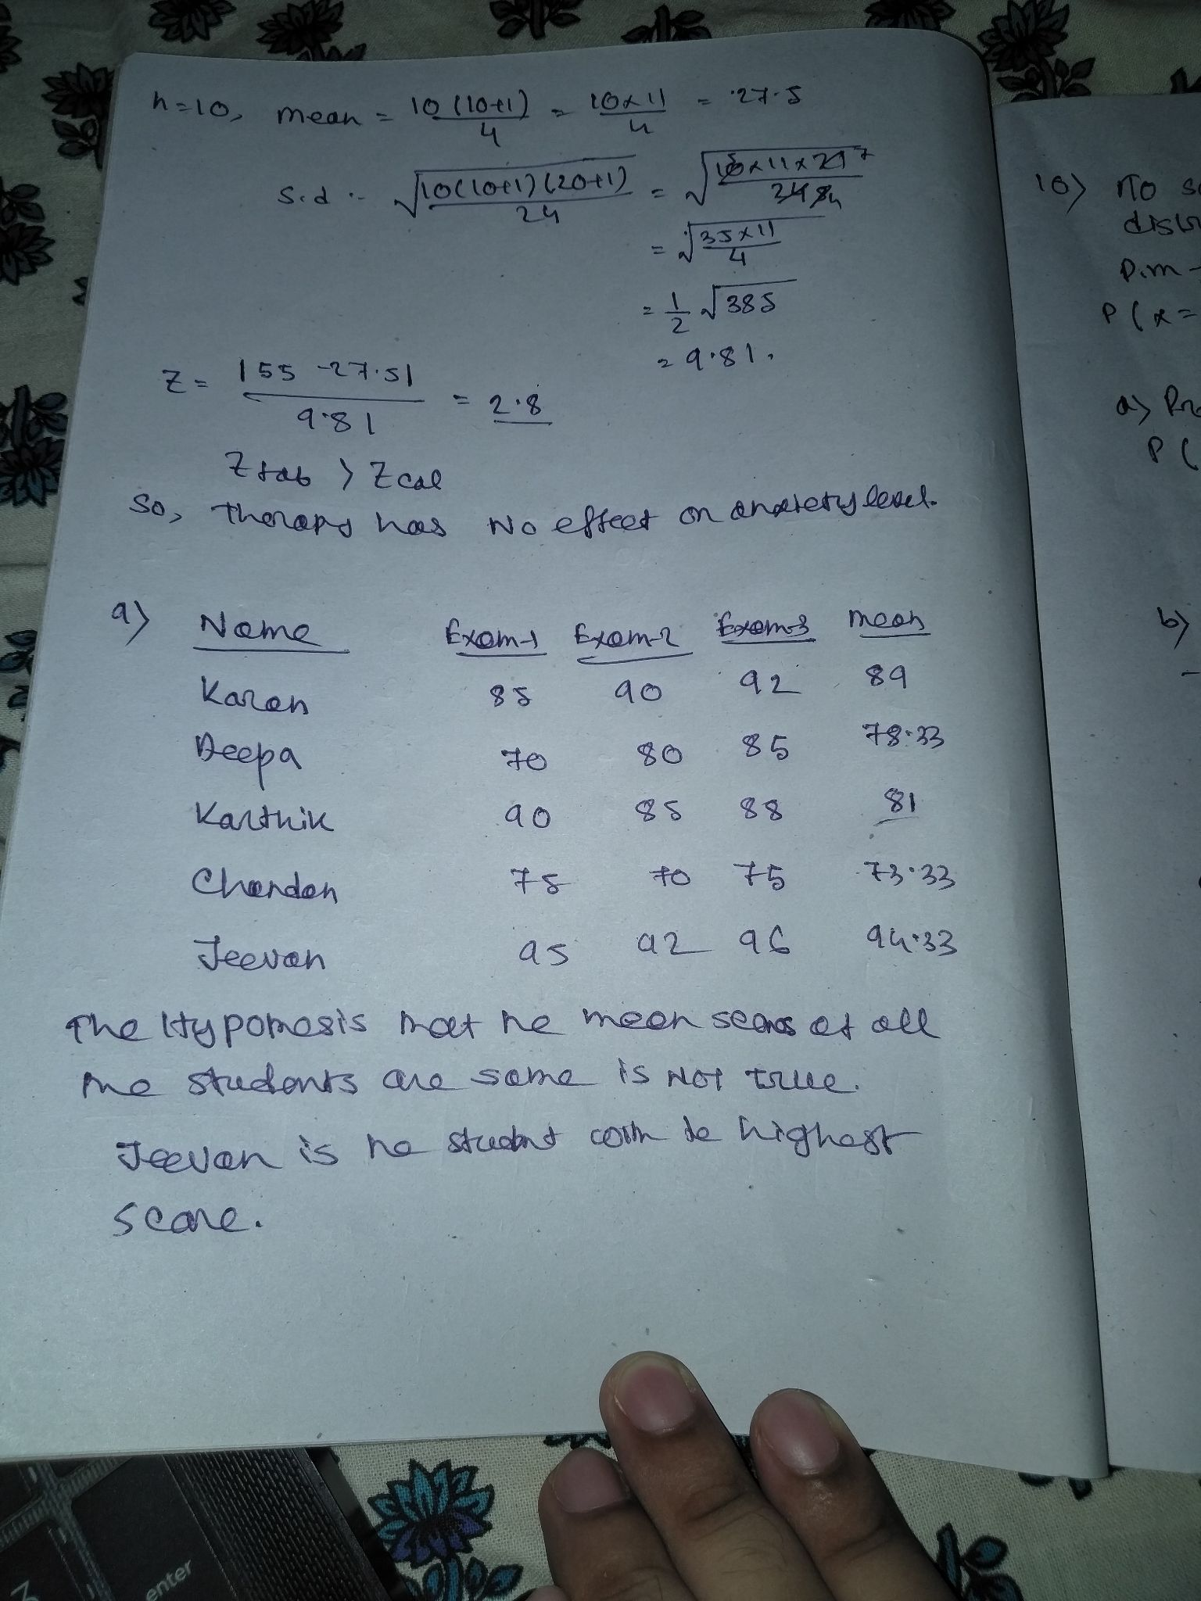

**Question-9:**

**Question-10:**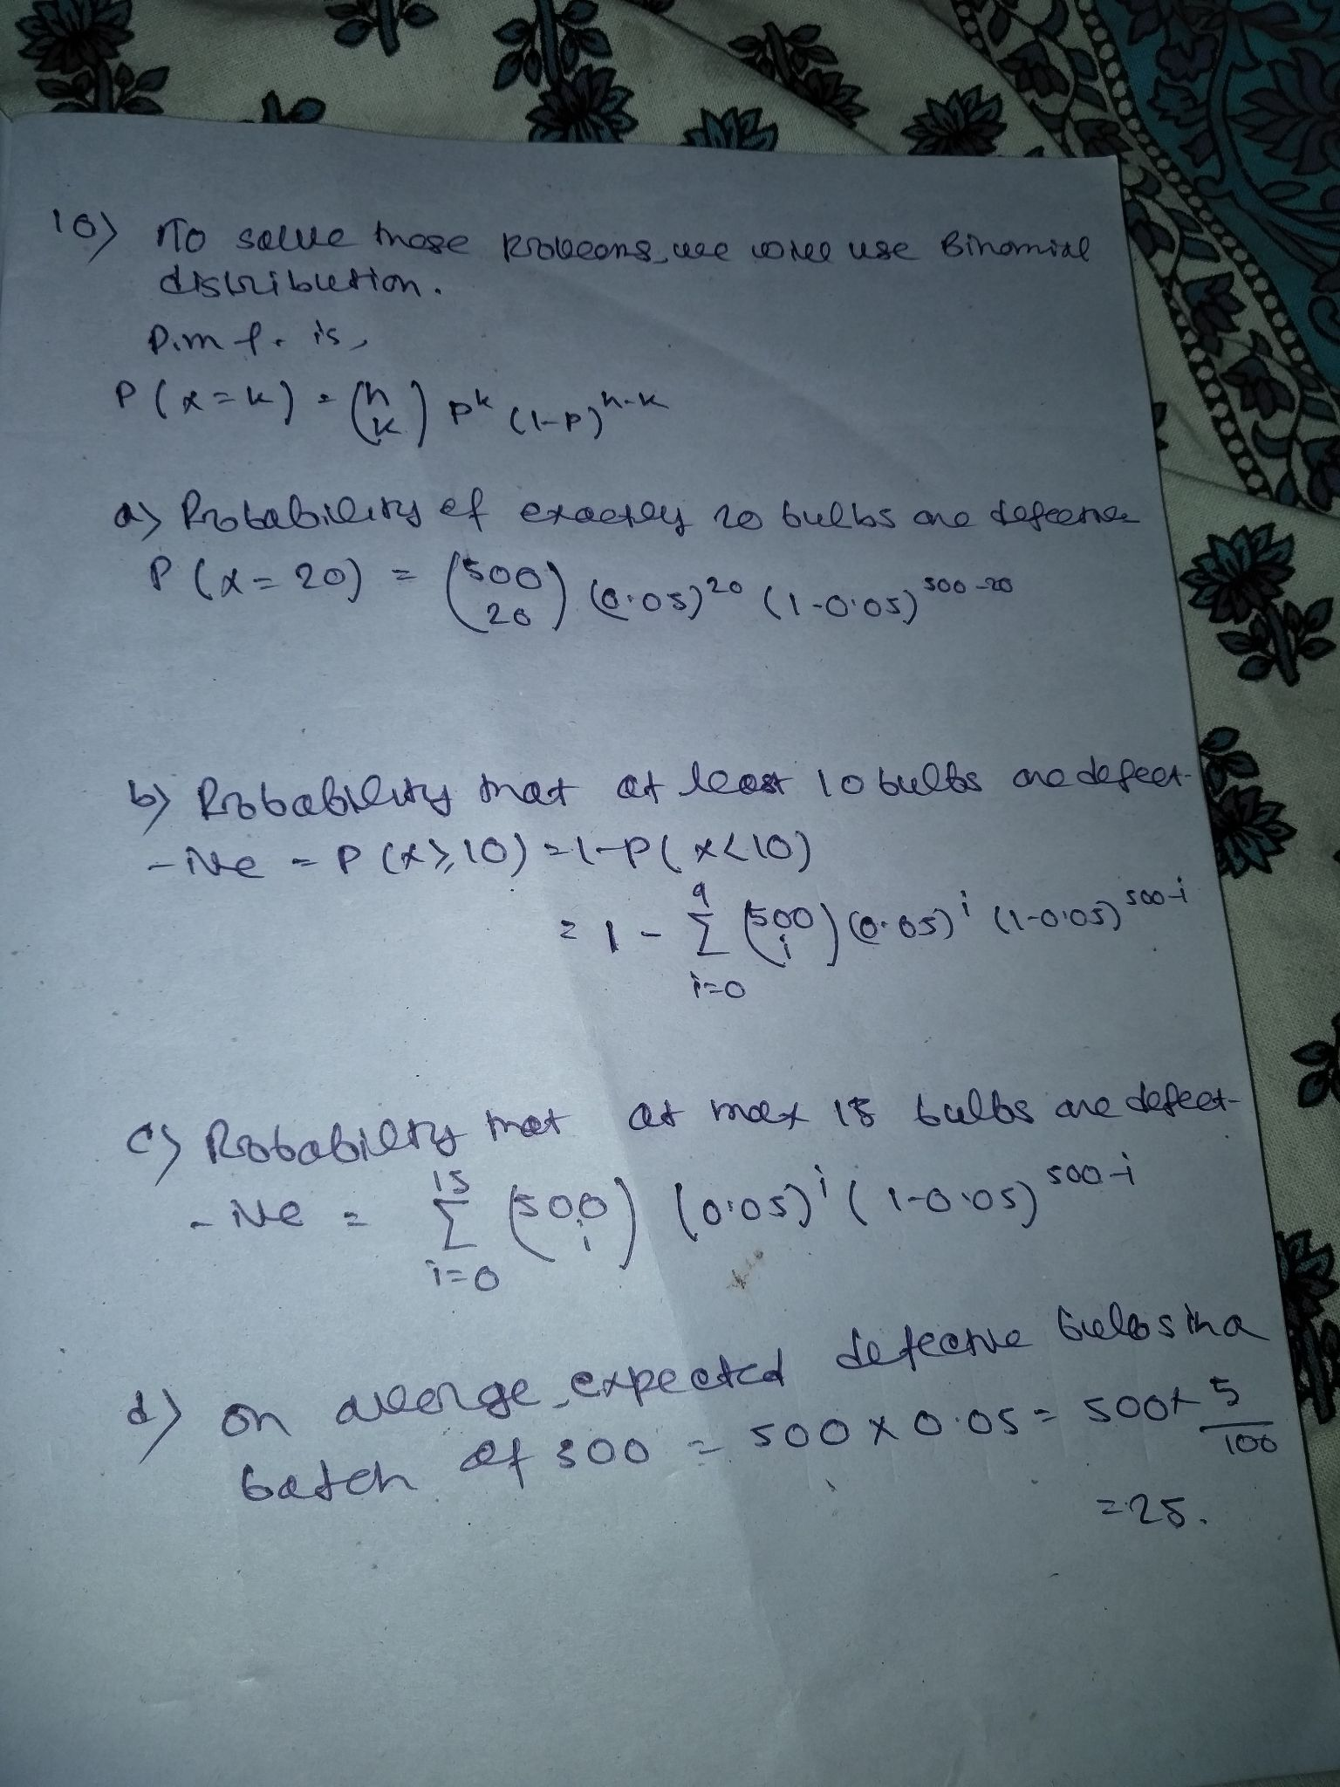

**Question-11:**

**Question-12:**

**PYTHON**

**Question-1:**

https://github.com/Apurba1721/Placements/blob/main/p1.ipynb